**DERIVATION**

Terms:

, a dichotomous random variable that alternates over time between two states



, random duration of state 0, with density function 

, random duration of state 1, with density function 

, the complementary cumulative distribution function for durations

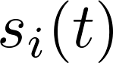, random elapsed time since entering state 

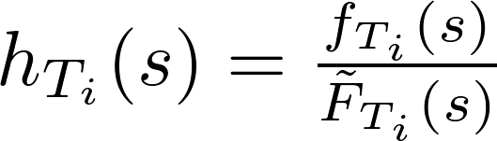, the hazard function.  Gives the probability of exiting state  in time interval , given that .

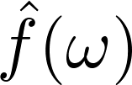, Fourier transform of a function 

...

For each of the two alternating states z = {0,1}, the rate of change in probability over time depends on the evolution of the s variable, the time since entering the current states. As ds/dt = 1, the advective flux of probability is simply f(x). From this quantity is subtracted the probability of exiting the current state.

 (1)

 (2)

The value of s is reset to 0 whenever an alternation between states occurs. The initial probability source at s = 0 is determined by the probability of switches out of the previous state, leading to the following boundary conditions:

 (3)

 (4)

Initial Conditions:

 (5)

…

Using these conditions, a solution can be found for 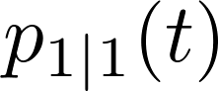:

 (6)

…

To find the probability 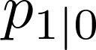, simply time shift the above expression by the durations of the initial state, 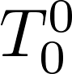, whose density function is 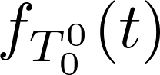-- the switch times are then described by 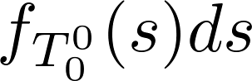. This amounts to a convolution of the density for initial durations with the previous solution:

. (7)

Thus the solution can be given in the Fourier domain as:

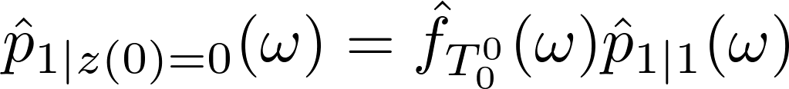. (8)

Using the simplifying assumption that 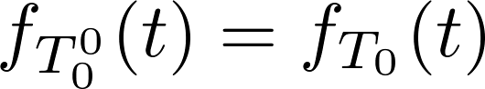, eg the first duration is from the same probability density as all other 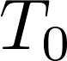, we find that:

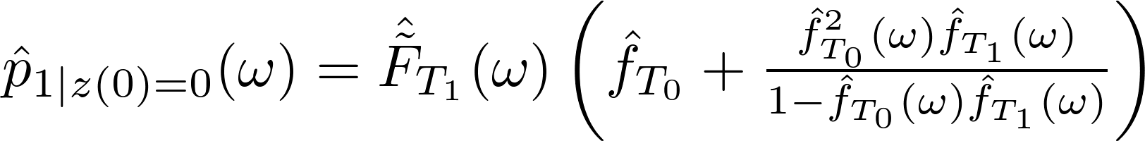 (9)

(Finishing up: at omega = 0, f_hat(omega) = mu_T1/(mu_T1 + muT0); ifft, integrate from 0 to t.)